Advanced
- [Array] Apple Stock. I have an array stockPricesYesterday where the keys are the number of minutes into the day (starting with midnight) and the values are the price of Apple stock at that time. For example, the stock cost $500 at 1am, so stockPricesYesterday[60] = 500. Write an efficient algorithm for computing the best profit I could have made from 1 purchase and 1 sale of an Apple stock yesterday
- [Array] Pairs with Given Sum, version 1. Given an integer array and a number k return all pairs of numbers that sum to k.
Example: 1. A [100 1 2 200 3 300] k = 7 Res = [] 2. A [8 -3 -1 3 4 5] k = 7 Res = [[-1, 8], [3, 4]]
- [Array] Pairs with Given Sum, version 2. Given two integer arrays and a number k. Return all pairs of numbers that sum to k. Each number of the pair has to be from a different array.
Example: 1. A [ 1 2 3 100] B [4 5 6] k = 7 Res = [[1, 6], [2, 5], [3, 4]] 2. A [] B[1, 2, 3] k=7 Res = []
- [Array] Kth Largest. Given 2 arrays of sorted integers return the kth largest element. Examples:
- A [1, 2, 3] B [4, 5] k = 7 Res = ‘undefined’
- A [1, 2, 3, 4, 5, 6, 7, 8, 9, 10] B [-3, -2, -1, 0, 1, 2, 3, 4] k = 7 Res = 2 (it’s not 3 because A + B = [-3, -2, -1, 0, 1, 1, 2, 2, 3, 3, 4, 4, 5, 6, 7, 8, 9, 10])
- [Array] Counting. Given a sorted array of 0’s and 1’s. Find out the no. of 0’s in it. Write recursive, iterative versions of the code. Example: 1. A [00001111] Res = 4 2. A[111111 Res = 0]
- [String] Unique Characters. Implement an algorithm to determine if a string has all unique characters. What if you cannot use additional data structures?
- [String] Replace all spaces. Write a method to replace all spaces in a string with '%20'. You may assume that the string has sufficient space at the end of the string to hold the additional characters, and that you are given the "true" length of the string. (Note: if implementing in Java, please use a character array so that you can perform this operation in place.)
Example: Input: "Mr John Smith" Output: "Mr%20John%20Smith"
- [String] Reverse words. Given a string containing a set of words separated by whitespace transform it to a string in which the words appear in the reverse order. For example, “Alice likes Bob” transforms to “Bob likes Alice”. We do not need to keep the original string.
- [String] Generate all permutations of string. Write a program which generates all permutations of a string. Tell the complexity of the solution.
- [String] Remove Duplicate. Design an algorithm and write code to remove the duplicate characters in a string without using any additional buffer.
NOTE: One or two additional variables are fine. An extra copy of the array is not. Write the test cases for this method.
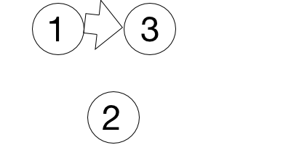
- [Graph] Find a ring road. In Milky Way galaxy there is a planet Neptune with N cities. Some of them are connected with roads. Some of those roads are one way roads. You need to print “Ring road” if there are roads that make a ring road, “Tree structure” - otherwise. Input: 1st row - N, number of cities, next N rows - adjacency matrix.
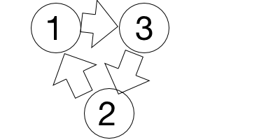
Input: Output: Input: Output:
3 Ring road 3 Tree structure
1 0 1 1 0 1
1 1 0 0 1 0
0 1 1 0 0 1
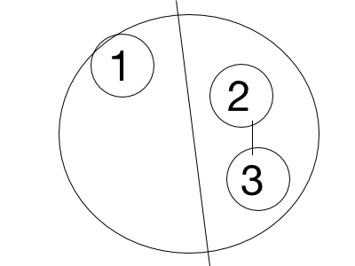
- [Graph] Is there another country? In Milky Way galaxy there is a planet Neptune with N cities. Some of them are connected with roads. If two cities are connected, they belong to the same country. You need to print all cities for each country. Input: 1st row - N, K, where N - number of cities, K - number of roads, next K rows - adjacency list.
Input: Output: Input: Output: Input: Output:
5 3 1 2 5 1 0 1 5 2 1 2
1 2 3 4 1 2 3
3 4 4 5 4 5
5 2
- [DP] Fibonacci Modified. A series is defined in the following manner:Given the nth and (n+1)th terms, the (n+2)th can be computed by the following relation T_{n+2} = (T_{n+1})² + T_{n}
So, if the first two terms of the series are 0 and 1: T₃ = 1^2 + 0 = 1 T₄ = 1^2 + 1 = 2 T₅ = 2^2 + 1 = 5.
Given three integers A, B and N, such that the first two terms of the series (1st and 2nd terms) are A and B respectively, compute the Nth term of the series.
Input: 0 1 5 Output: 5
- [DP] Minimum Number of Coins. Given a list of N coins, their values (V₁, V₂, ... , V_{N}), and the total sum S. Find the minimum number of coins the sum of which is S (we can use as many coins of one type as we want), or report that it's not possible to select coins in such a way that they sum up to S.
Input: Input:
5 10 5 3
1 1 1 1 2 1 2 3
Output: Output:
0 1
- [DP] Bricks Game. You and your friend decide to play a game using a stack consisting of N bricks. In this game, you can alternatively remove 1, 2 or 3 bricks from the top, and the numbers etched on the removed bricks are added to your score. You have to play so that you obtain the maximum possible score. It is given that your friend will also play optimally and you make the first move. Input: first line will contain a number N i.e. number of elements in the stack and next line will contain N numbers i.e. numbers etched on bricks from top to bottom.
5 5
999 1 1 1 0 0 1 1 1 999
Output: 1001 Output: 999
- [Linked List] Nth to Last Element. Implement an algorithm to find the nth to last element of a singly linked list.
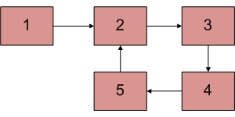
- [Linked List] Detect and Remove Loop in a Linked List. Write a function detectAndRemoveLoop() that checks whether a given Linked List contains loop and if loop is present then removes the loop and returns true. And if the list doesn’t contain loop then returns false.
Example: Below diagram shows a linked list with a loop. detectAndRemoveLoop() must change the below list to 1->2->3->4->5->NULL.
- [Queue, Stack] Queue with two stacks. Implement a queue with two stacks so that each queue operations takes a constant amortized number of stack operations.
- [Queue, Stack] Stack with two queues. Implement a stack with two queues.
- [Queue, Stack] Stack with max. Create a data structure that efficiently supports the stack operations (push and pop) and also a return-the-maximum operation. Assume the elements are real numbers so that you can compare them.
- [Queue, Stack] Infix to Postfix Conversion. Given an expression in infix notation return it in postfix notation. An infix expression is one in which operators are located between their operands. In postfix notation, the operator immediately follows its operands. ‘X + Y’ becomes ‘XY+’ in postfix notation. Example: 1) input: 3+4 output: 3 4 +
2) input: (300+23)*(43-21)/(84+7) output: 300 23 + 43 21 - * 84 7 + /
- [Queue, Stack] King and Knight. Given a king and a knight on an infinite chessboard (no boundary), each takes turn to move (i.e. the king moves first, then the knight can move, then the king moves again and so on). Find the minimum number of moves until they meet at the same square.
- [Queue, Stack] Duplicate parenthesis. Give an algorithm for finding duplicate parenthesis in a expression. Example: {{ (( a + b ) * (( c + d ))) }}
- [Queue, Stack] Implement LRU Cache. How to implement LRU caching scheme? What data structures should be used? We are given total possible page numbers that can be referred. We are also given cache (or memory) size (Number of page frames that cache can hold at a time). The LRU caching scheme is to remove the least recently used frame when the cache is full and a new page is referenced which is not there in cache.
- [Binary Tree] Verify BST. Given the root of a binary tree, verify whether or not the tree is a binary search tree.
- [Binary Tree] Paths with Specific Sum in Binary Tree. Given a binary tree and a number, please print out all of paths where the sum of all nodes value is same as the given number.
Example: For instance, if inputs are the binary tree in the given figure and a number 22, two paths with be printed: One is the path contains node 10 and 12, and the other contains 10, 5 and 7.
- [Binary Tree] Binary Tree with Minimum Height. Given a sorted (increasing order) array, write an algorithm to create a binary tree with minimal height
- [Binary Tree] Delete Node from BST. Implement a function which delete a node from a binary search tree.
- [Binary Tree] Linked list from BST. Given a binary search tree, design an algorithm which creates a linked list of all the nodes at each depth (eg, if you have a tree with depth D, you’ll have D linked lists).
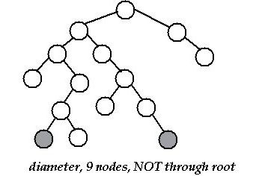
- [Binary Tree] Create a binary tree from Mathematical Expression. If you are given an infix/postfix expression, make an expression tree out of it. Eg. Convert a postfix expression into an expression tree
- [Binary Tree] Diameter of a Tree. Find a diameter of a tree which is the longest path between two leaf nodes in a tree.
- [Binary Tree] Closest Node BST. Given a binary search tree and a value k. Find a node in the binary search tree whose value is closest to k.

